

BLACK LION PROJECT

IT CAPSTONE: CIS 2910C



FALL 2024

VALENCIA COLLEGE

J. McAllister, J. Lopez, J. Ferreira, V.R. Johnson

Contents

Prologue: 2

Overview: 3

Planning: 4

Design: 5

Deployment: 6

Testing: 7

Monitoring: 8

# Prologue:

The Black Lion Project invites you, a wistful, disciplined and productive tech user, to an exclusive experience. A revolutionary and secure site in the Personal Admin Launcher or P.A.L. Our system offers new and existing users the convenience of an event planner on the PC platform.

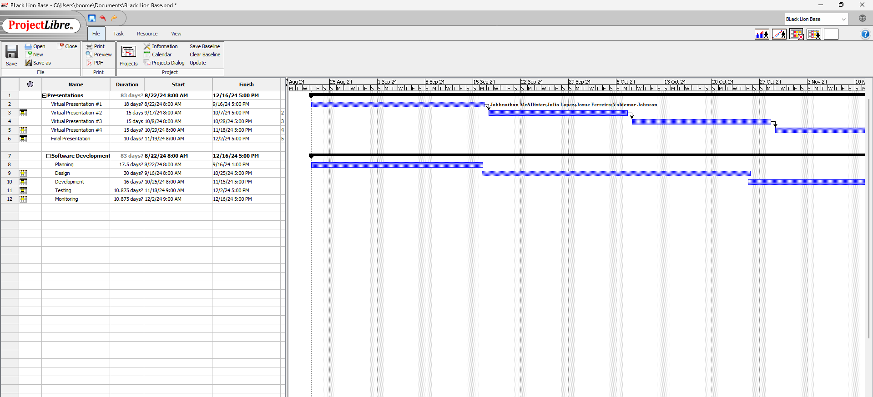

Roles:

Josue Ferreira - Software Development Designer (Front-end: HTML, CSS)

Julio Lopez – Software Development Engineer (Back-end: Python), Repositories, MySQL

Johnathan McAllister – Database Hosting & Network Engineer, IT Support

Valdemar Johnson – Project Management, IT Support, Writer

# Overview:

This image provides a brief overview of our network diagram. Essentially because we would rely on Amazon Web Services, a site where we could launch instances or code to our official domain using S3.

Then employed our database to secure user credentials by encrypting the logged password. This was a necessary security measure to ensure data does not leak by malicious users. AWS Fargate was the leading tool to update coding after changes were prepared.

# Planning:

During our planning phase our Team’s prioritized goal was to expand on the building blocks we had all developed over the length of our degrees. This meant all the projects, sites, skills, and experiences we had accumulated had been brought forth. This notion helped the Black Lion Project formulate its roles for each member. It is important that we all played to our strengths; this was a philosophy we each shared because we understood it would help lead to the best results.

|  |  |  |
| --- | --- | --- |
| **INPUT** | **PROCESS** | **OUTPUT** |
| Registration Credentials | * Func: prompt allowing users to fill [x] info to create profile. * Info is logged with database. | User able to login freely |
| Create an event | * Func: prompt users to fill in form important to the event. * Results stored in a variable. | Events displayed in a list |
| Sign-out | * Func: Will exit/force user to sign in. | Log the user out of their account |

Planning required us all to be on the same page. We each agreed the website would function to allow users to create a profile and revisit their work afterwards. An IPO was useful for us to create a flow within the site, mimicking the process a typical user would be prompted to. Meaning not including a sign-out feature was unauthentic from the teams’ perspective.

From then it was about sticking to the plan. Project Libre provided our team with visible deadlines. And Visio gave us an idea of our most critical path. And GitHub was important for submitting repositories.

# Design:

Black Lion’s approach with the design required our team to plan based on building blocks of our collective experiences. This essentially translates to we wanted to develop an experience that we ourselves could use in an everyday circumstance.

Our approach for the design concept meant having a few pages with each having a distinct role. Our landing page introduces the user to the vision of Black Lion, and we all decide on a consistent theme to implement across the entire domain.

We were excited to allow users to edit their custom events to adjust for changes and updates in their plans. This shows depth in the functionality of the site because even a full-time student can update events along the course of a semester, for example, in case of poor weather and exam dates being rescheduled.

# Deployment:

On the development front we had to decide exactly how we intended to deploy our domain. Ultimately, we decided on implementing AWS instances to deploy our domain. We all concluded this would be the most efficient solution.

*This script is important for our deployment as it connects the Python script to MySQL database hosted on AWS RDS to enable a structure. *

# Testing:

Our testing phase consisted of each of us making various accounts to test the overall framework. An email is required along with a list of other credentials. We then utilize this data including our client’s password and store all metadata in privately secure servers.

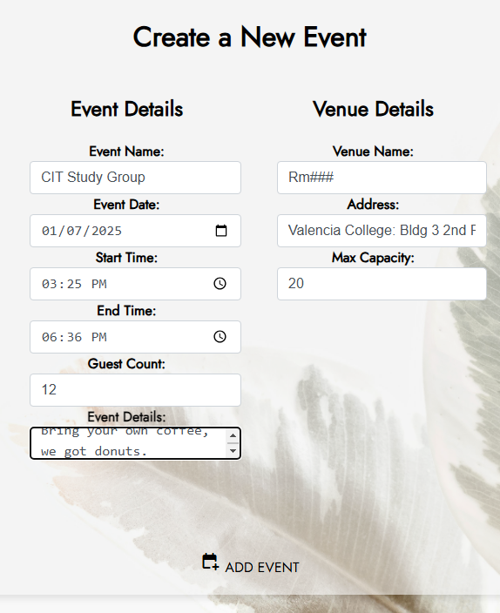

Once we could identify any issues, reports by the Project Manager were forwarded to our Lead Development Engineer.

This was an interesting process, digging into the corners of each function. And revising defensive testing to ensure the user could have secure navigation amidst the server. As the testing process continued, we were validated that not only could the site function toward event wedding planning but also typical events from a wide range.

# Monitoring:

Since launching the base version of [PAL](http://eventplanner.lopezbio.com/login) a handful of tweaks have been issued to update and finalize the appearance and experience on the site. We as a team have been working diligently to continue to make massive improvements. That is because we feel that is the respect The Black Lion Project and PAL deserve an intuitive sanctuary where users from project managers to schoolteachers can rely on in their everyday lives.

Reflection Questions:

What did The Black Lion Project want to offer with PAL? With the personal admin launcher, we set out to provide a solution for the woes of daily planning and organization. PAL was then defined as an event planner, yet functions more as a desktop assistant. It offers live weather forecasts, a list of detailed events controlled by the user on a secure database.

How much has it cost you to develop an Event Planning PAL? The idea of building a site that offers registered users a destination to organize events seemed like a daunting task in the beginning. After careful planning and research, the Black Lion Project has manufactured our full stack in house. From front-end, to back-end, and networking in between, PAL leads to a zero net cost to build and maintain.

Do you believe ethically P.A.L. will have a net impact positive? We believe a user could be tech-savvy and disorganized at the same time. Our platform is for those hoping to prepare for busy days ahead, this is why PAL operates best as a wedding planner yet is not limited to this specific function.

Who is the PAL site meant for exactly? Couple on a budget planning a wedding? Mom planning summer events for the kids? Veteran college professor brainstorming deadlines, projects, while monitoring conventions? All can be done from the PAL site because its data, including your events is kept on a secure list.

How is it deployed? Using AWS. We utilized GitHub, and a range of AWS services for our repositories in case of any changes. Then theoretically we could redeploy our instance on AWS to reflect said changes.

What is your next mission after completing EP PAL? Now we are wrapping some vital monitoring processes until we garner all the feedback on our deliverables from our client. As for the team, members have drawn up ideas for future ventures.

Did the project come out to your Team's expectations? Yes, our project has exceeded our expectations in fact. In the beginning we all agreed this would be an experience that would merit a spot in each of our portfolios.